图9.1 1861年到2005年全球地表平均温度变化

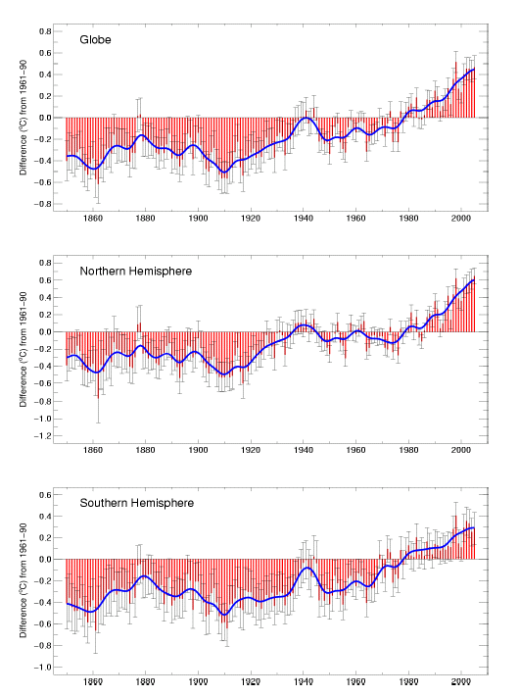

Global and hemispheric annual combined land surface air temperature and SST (°C) (red) relative to the 1961–1990 mean, along with ±2 standard error ranges, from HadCRUT3 (Brohan et al., 2006).
图9.2 1901年到2005年全球地表平均温度变化趋势。

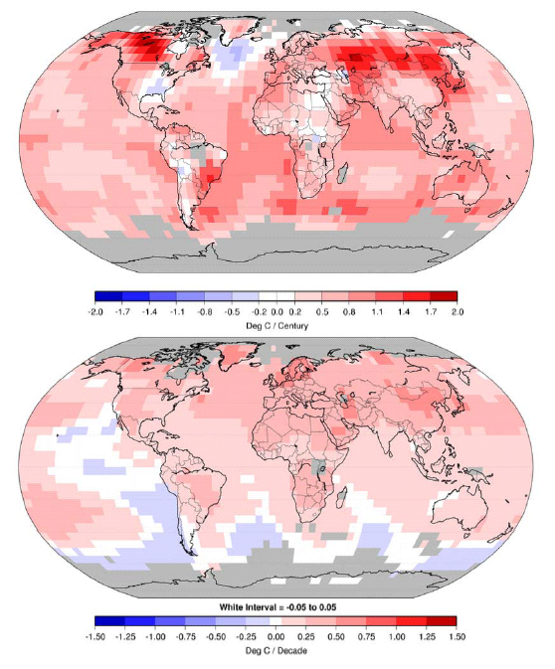
Linear trend of annual temperatures for 1901–2005 (upper; °C century^{–1}) and 1979–2005 (lower; °C decade^{–1}). Areas in grey have insufficient data to produce reliable trends. The minimum number of years needed to calculate a trend value is 66 years for 1901–2005 period and 18 years for 1979–2005. An annual value is available if there are 10 valid monthly temperature anomaly values. The dataset used was produced by NCDC from Smith and Reynolds (2005).

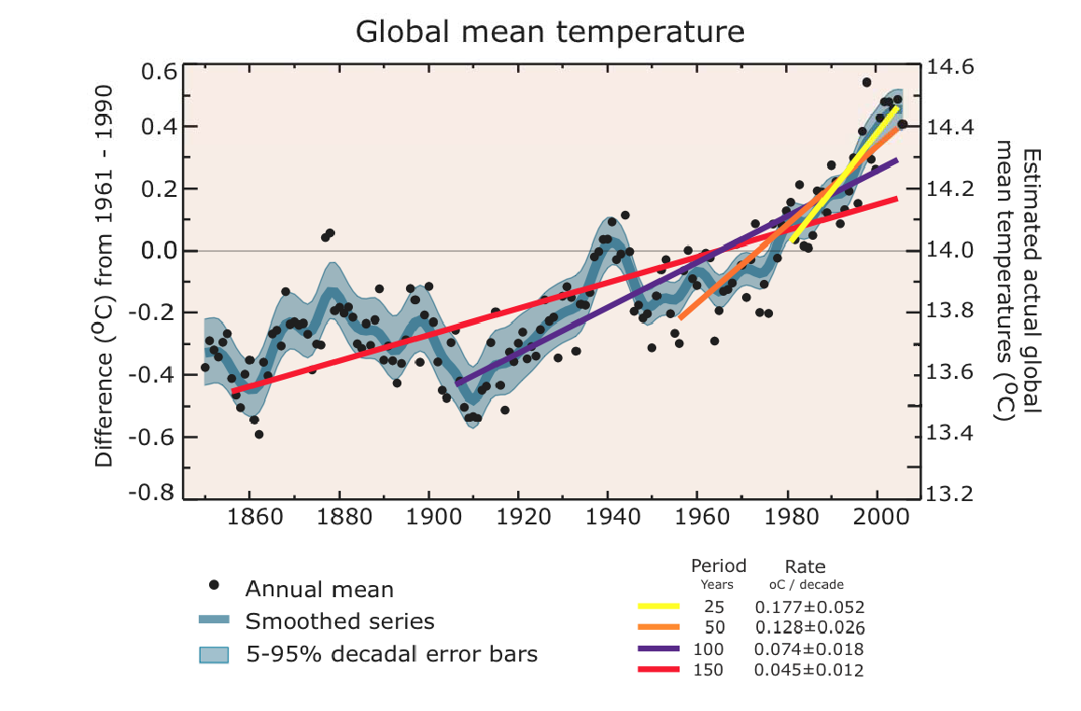
多模式平均和地表增暖范围评估结果
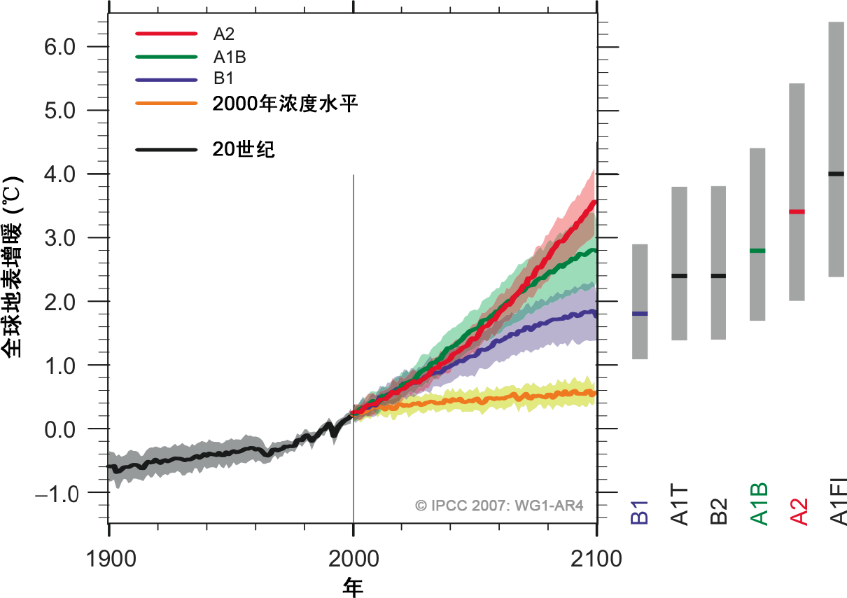
图SPM–5. 各实线分别表示A2、A1B和B1情景下的多模式全球平均地表增暖（相对于1980至1999年平均），并作为20世纪模拟结果的延续，阴影区表示各模式年值的正负一个标准差范围。橘红色线表示将控制在2000年浓度水平上的模拟试验结果，右侧的灰色条表示最佳估算值（各条中间的实线）和六个SRES标志情景可能性范围的评估结果。对灰色条中最佳估算值及其可能性范围的评估结果，包括图左边的海气耦合模式结果，以及一系列单个模式和观测约束和结果。{图10.4和10.29}

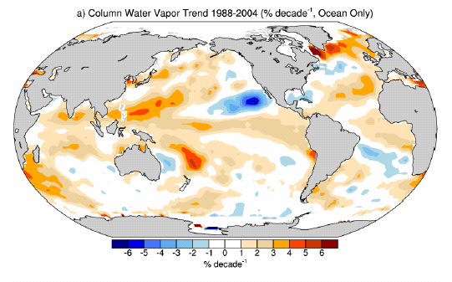
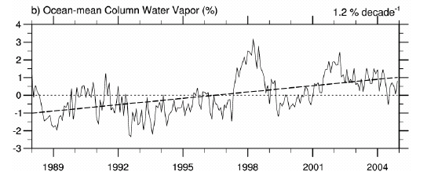

Figure Linear trends in precipitable water for 1988–2004 in % per decade (top) and monthly time series of anomalies over the global ocean plus linear trend (bottom), from RSS SSM/I (updated from Trenberth et al., 2005).

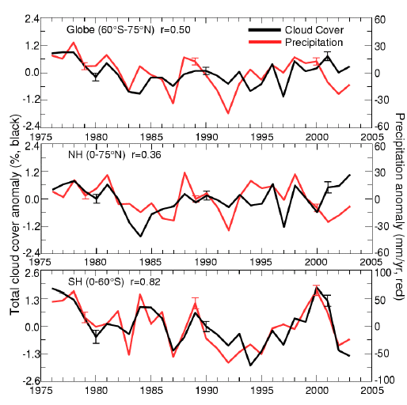
Figure Annual total land (excluding the U.S. and Canada) cloud cover (black) and precipitation (red) anomalies from 1976 to 2003 over global (60°S–75°N), NH and SH regions, with the correlation coefficient (r) shown at the top. The cloud cover is derived by gridding and area-averaging synoptic observations and the precipitation is from Chen et al. (2002). Typical error bars for each decade are one standard error estimates using inter-grid-box variations (from Dai et al., 2006)

.

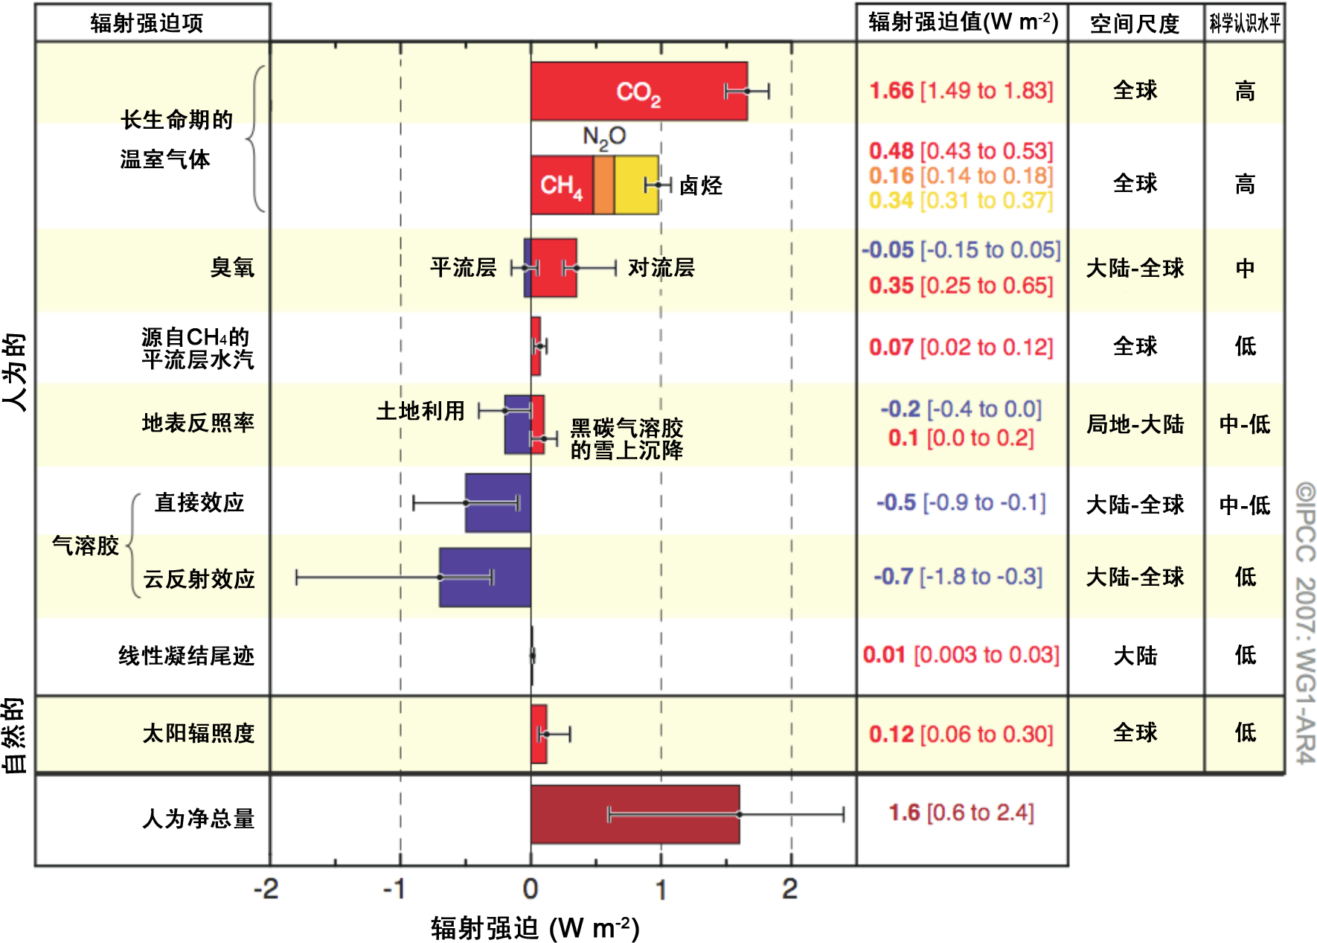

2005年全球平均辐射强迫（RF）估算值及其范围，包括人为二氧化碳（CO2）、甲烷（CH4）、氧化亚氮（N2O）和其他重要成分和机制，以及各种强迫的典型地理范围（空间尺度）和科学认识水平（Level of Scientific Understanding，LOSU）的评估结果，同时给出人为净辐射强迫及其范围。这些需要计算各分量的非对称不确定性估算值的总和，不能用简单叠加得到。这里未包含的其他强迫因子被认为存在很低的科学认识水平。火山气溶胶是又一种自然强迫，但鉴于其阶段性特性，故未包含在此图内。线性凝结尾迹的范围不包含其他的航空对云的可能影响。{2.9, 图2.20}

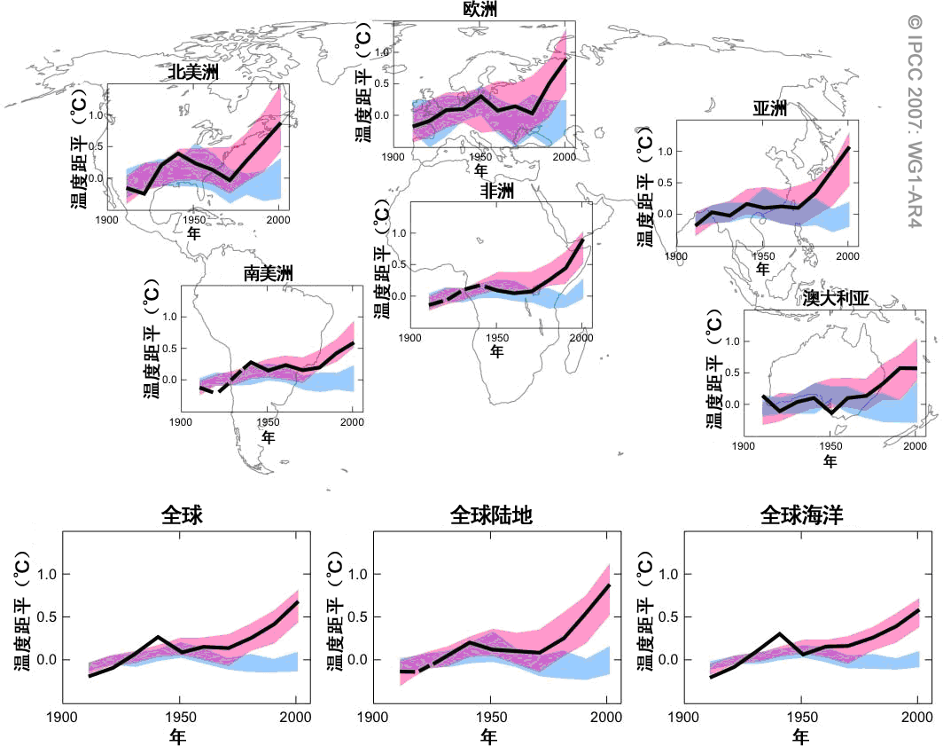

观测到的大陆与全球尺度地表温度与使用自然和人为强迫的气候模式模拟结果的对比。相对于1901至1950年相应平均值，1906至2005年观测到的年代际平均值（黑线）绘于年代中心。虚线部分表示空间覆盖率低于50%。蓝色阴影表示仅使用太阳活动与火山自然强迫的5个气候模式19个模拟试验结果的5至95%置信区间。红色阴影表示同时使用自然强迫和人为强迫的14个气候模式58个模拟试验结果的5至95%置信区间。{问题9.2, 图1}

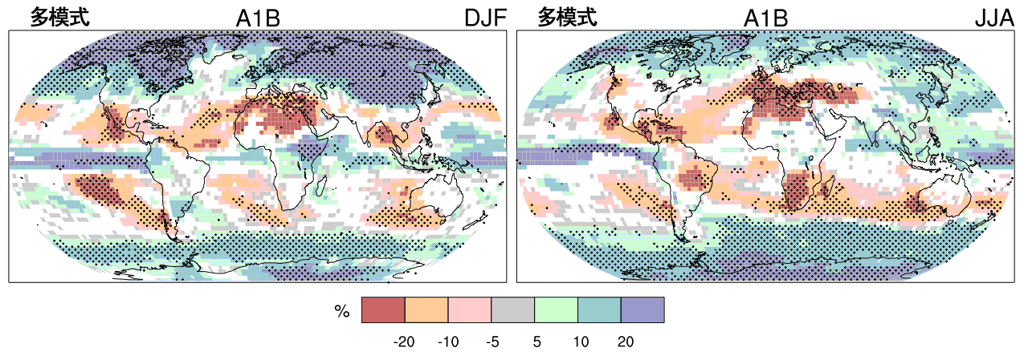
相对于1980至1999年平均的2090至2099年降水（百分率）变化。图中所示为SRES A1B情景下12至2月（左图）、6至8月（右图）的多模式平均结果。白色区域为模式变化符号一致性少于66%的区域，点状区域为模式变化符号一致性多于90%的区域。{图10.9}

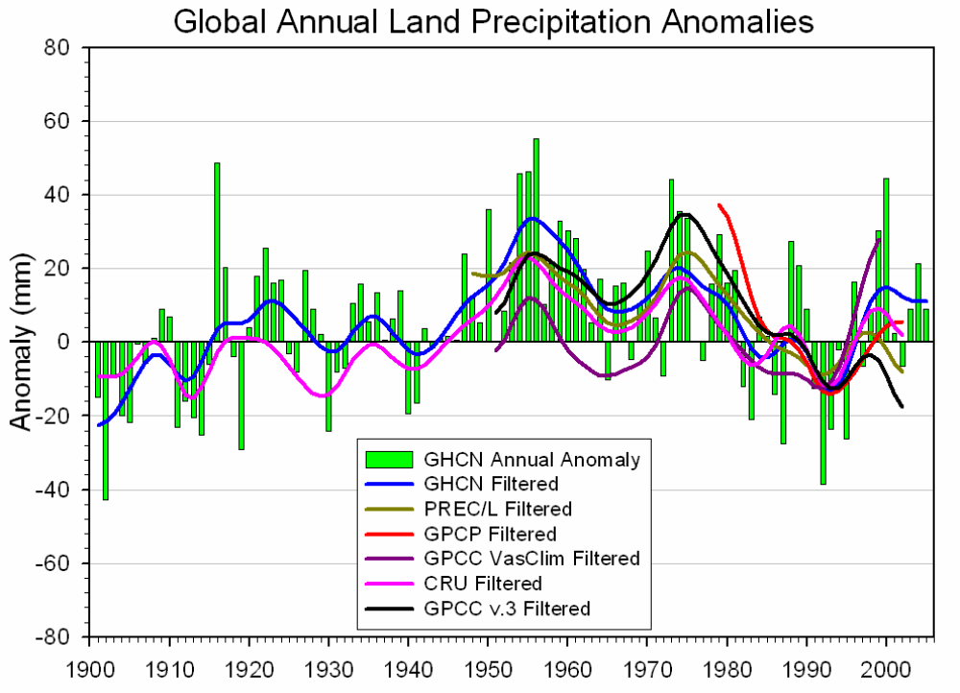

Time series for 1900 to 2005 of annual global land precipitation anomalies from GHCN with respect to the 1981–2000 base period (to convert to mm/day divide by 365 or 366). Smoothed values (using the decadal filter in Appendix 3.A) are also given for the GHCN (Peterson and Vose, 1997), PREC/L (Chen et al. (2002)), GPCP (Adler et al., 2003), GPCC (Rudolf et al., 1994) and CRU (Mitchell and Jones, 2005).

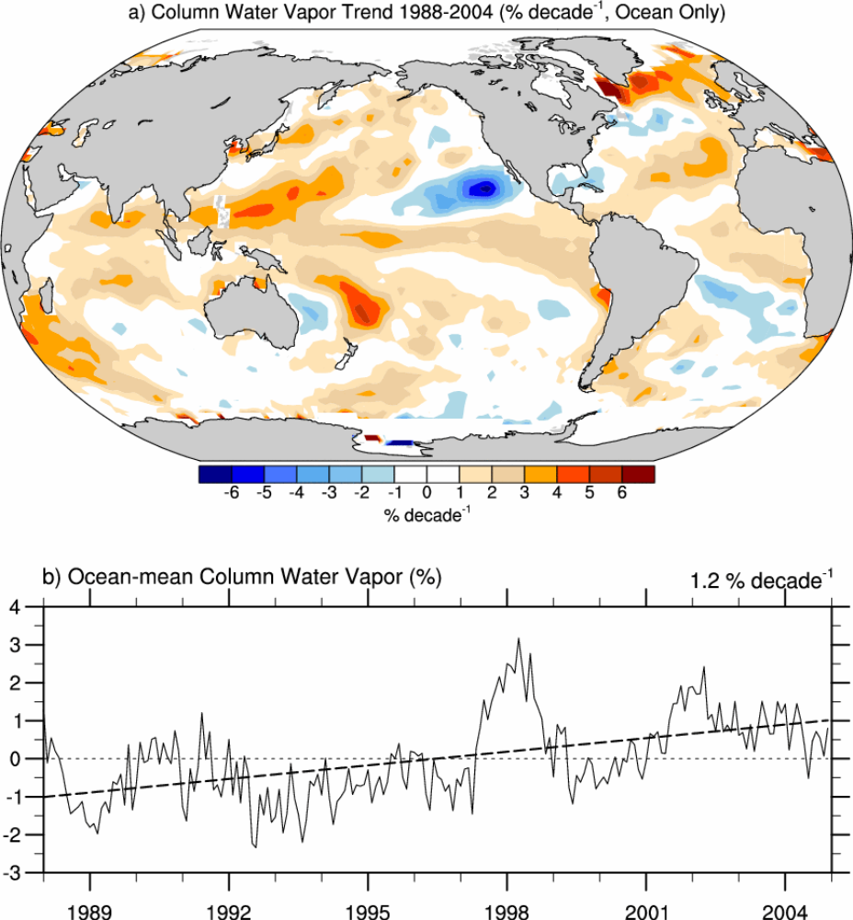

Linear trends in precipitable water for 1988–2004 in % per decade (top) and monthly time series of anomalies over the global ocean plus linear trend (bottom), from RSS SSM/I (updated from Trenberth et al., 2005).

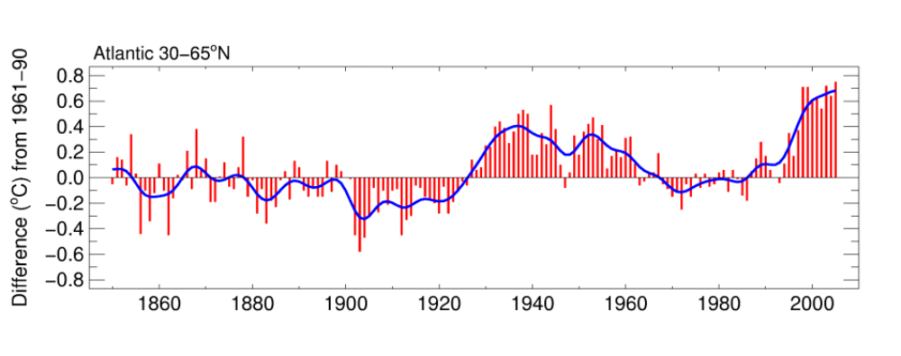
Atlantic Multidecadal Oscillation index 1850–2005 represented by annual anomalies of SST in the extratropical North Atlantic (30–65°N) (top), The series come from HadSST2 (Rayner et al., 2006) and are relative to 1961–1990 mean (°C).

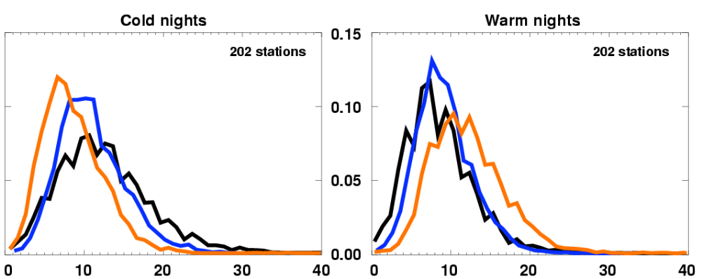

Annual probability density functions for temperature indices for 202 global stations with at least 80% complete data between 1901 and 2003 for 3 time periods: 1901–1950 (black), 1951–1978 (blue) and 1979–2003 (red). The x-axis represents the percentage of time during the year when the indicators were below the 10th percentile (left) for cold nights or above the 90th percentile (right) for warm nights. From Alexander et al. (2006).

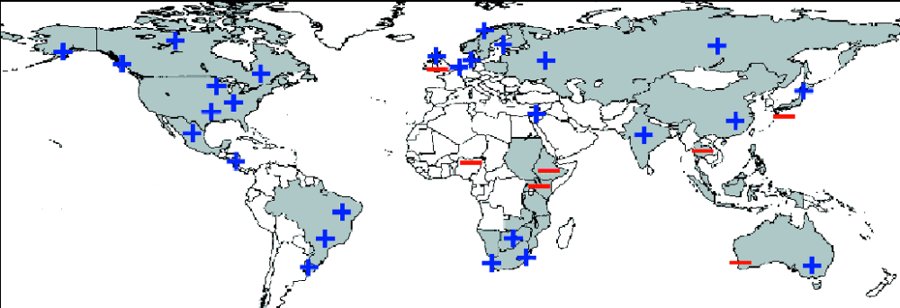

Regions where disproportionate changes in heavy and very heavy precipitation during the past decades were documented compared to the change in the annual and/or seasonal precipitation (updated from Groisman et al., 2005a). Thresholds used to define “heavy” and “very heavy” precipitation vary by season and region. However, changes in heavy precipitation frequencies are always higher than changes in precipitation totals and, in some regions, an increase in heavy and/or very heavy precipitation occurred while no change or even a decrease in precipitation totals was observed.

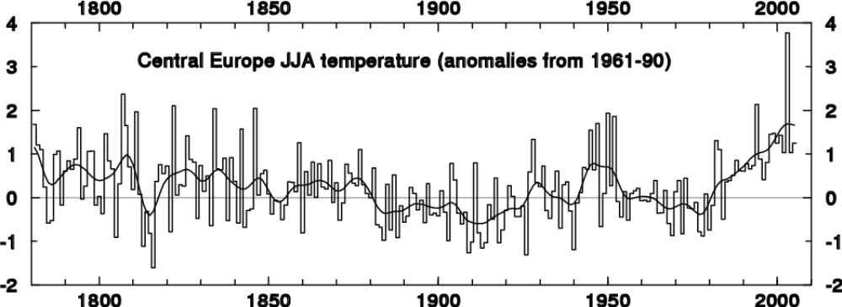

Long time series of JJA temperature anomalies in Central Europe relative to 1961–1990. In the summer of 2003 the value of 3.8°C far exceeded the next largest anomaly of 2.3°C in 1807 (Beniston and Diaz, 2004)

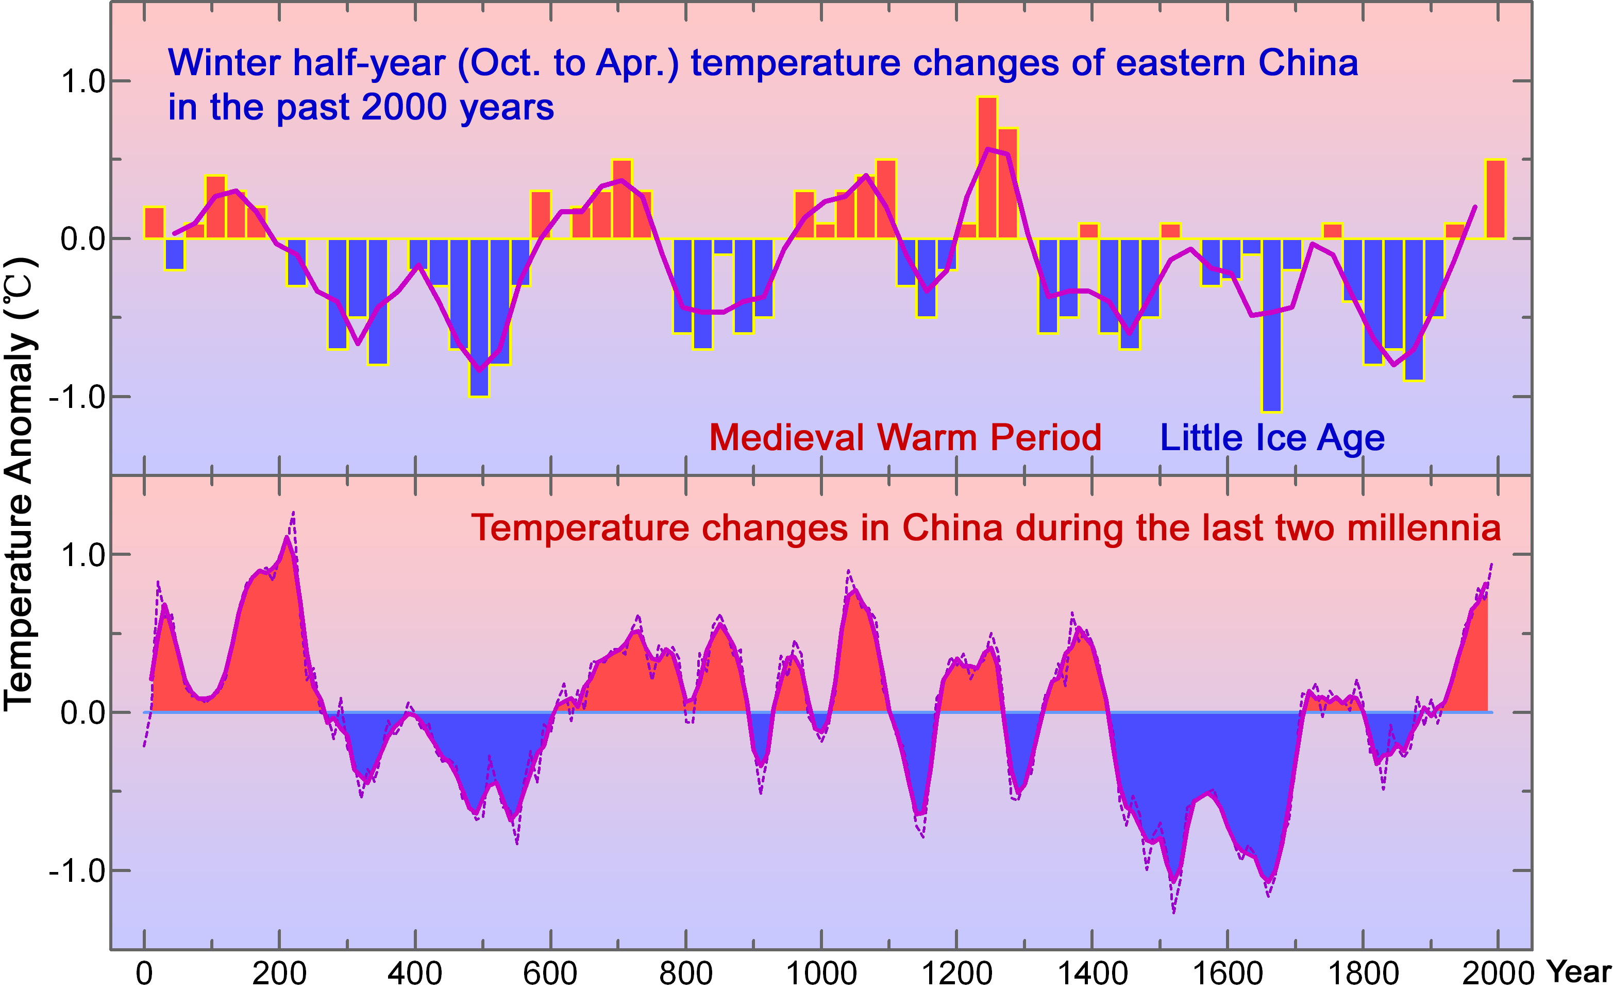

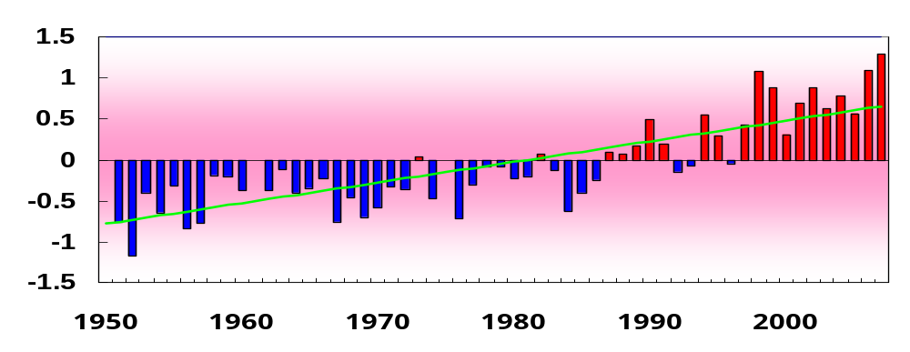

Annual temperature variation of China from 1951 to 2007, relative to the period 1971-2000

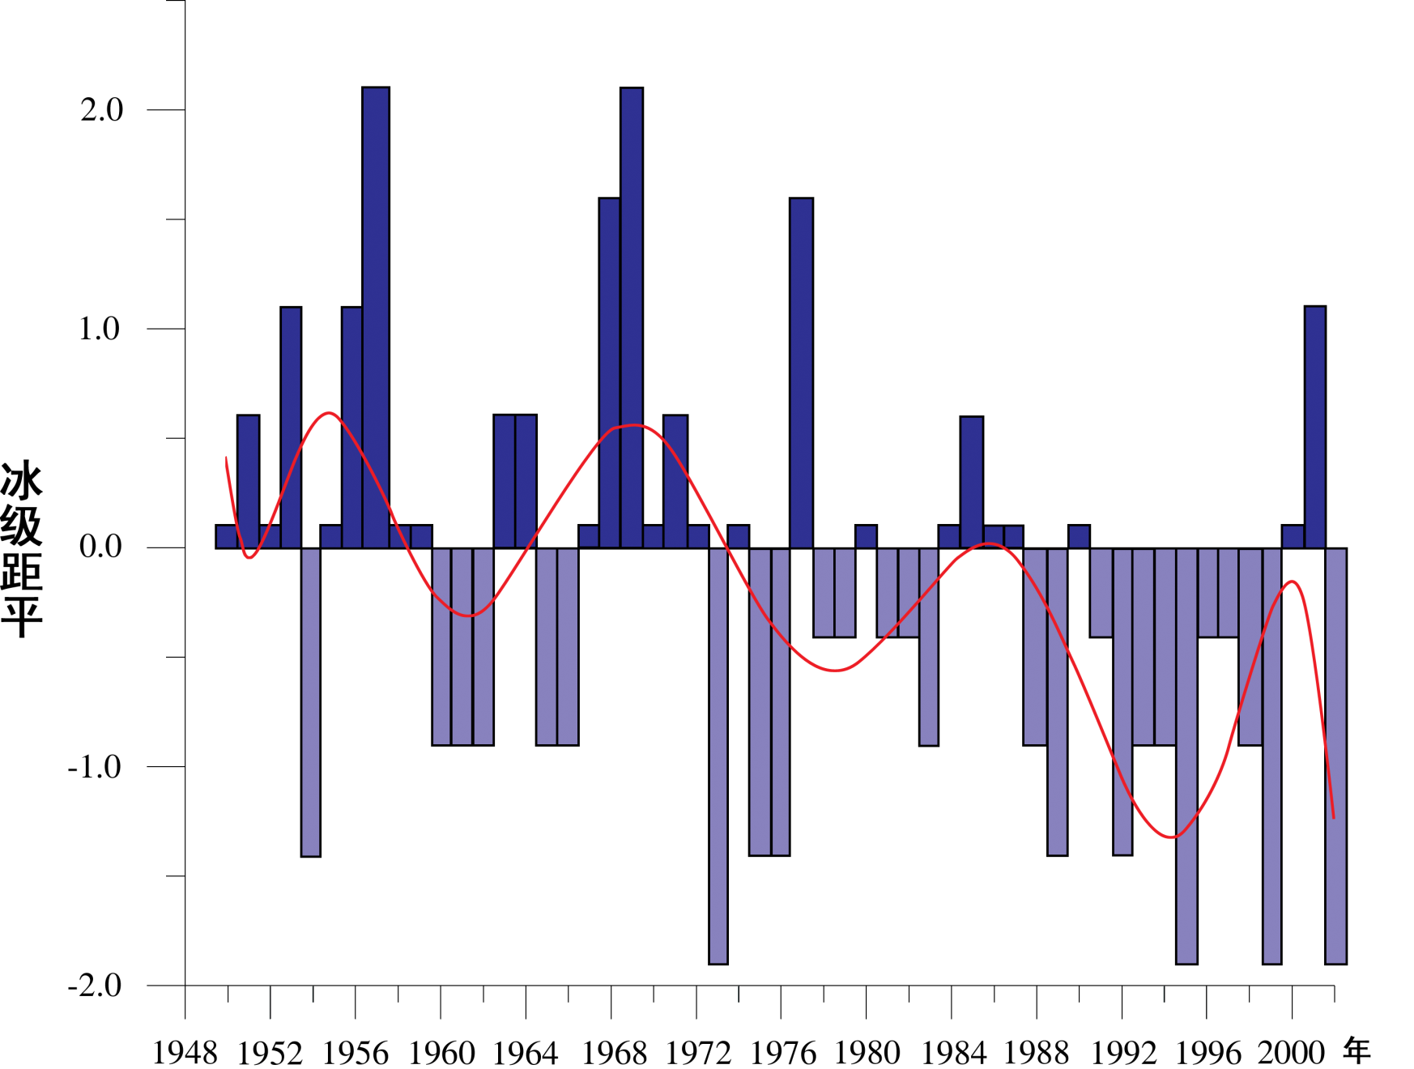
Sea Ice Grade

Deviation change of sea ice grade in the Bohai Sea and the Yellow Sea from about last 50 years. From Qin, et al., 2005

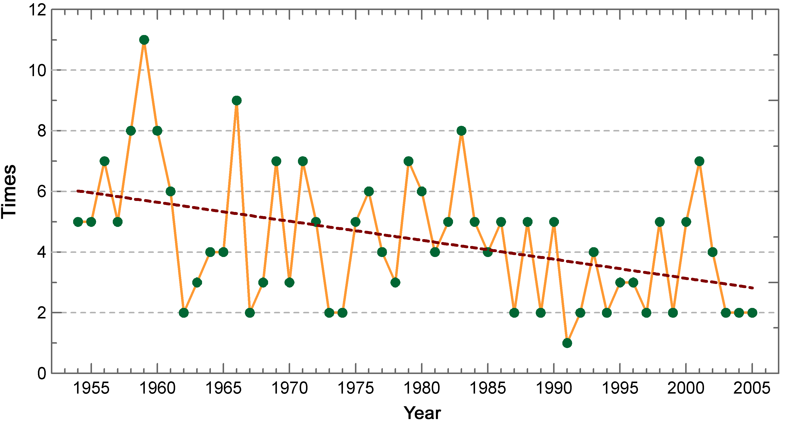

Occurrence of measured sand and dust storm in Northern China from 1954 to 2005

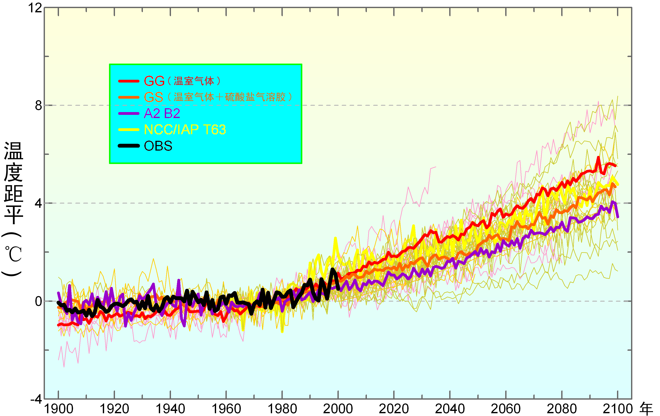

Simulation and Projection on air temperature in 20th and 21th century in China by climate models based on different scenarios. National Climate Center, CMA

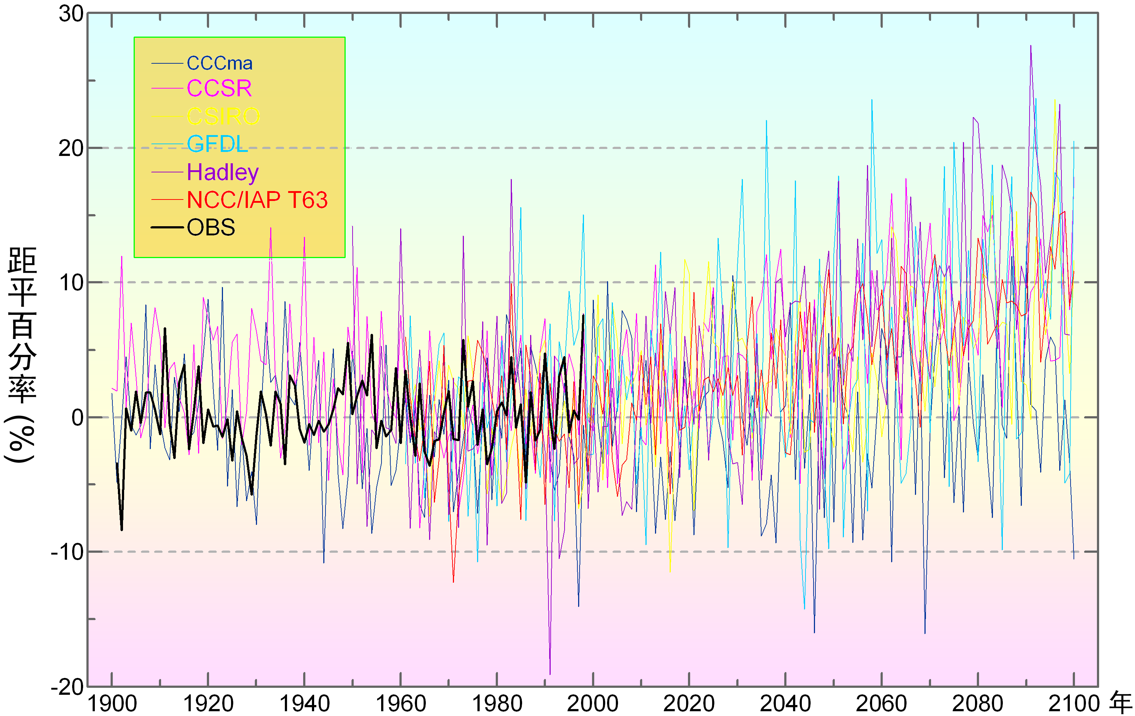

Precipitation variation of 21th century in China simulated by several IPCC models based on 4 emission scenarios . National Climate Center, CMA

